September 6th, Task Force Meeting notes

What Makes this community special to you?

“There’s never a dull moment in the community” - C

“SouthEast Texas is Texas’ greatest earner… Many great people make this area great” - J

“We are all connected” - C

“We are family oriented” - K

“People Coming together” - C

“We are a valuable resource for people everywhere… 25% of Jet fuel is made right here” - D

“The natural resources that we have..this area has provided for us” - E

“In times of need no matter our differences you see a family” “Natural resources” - A
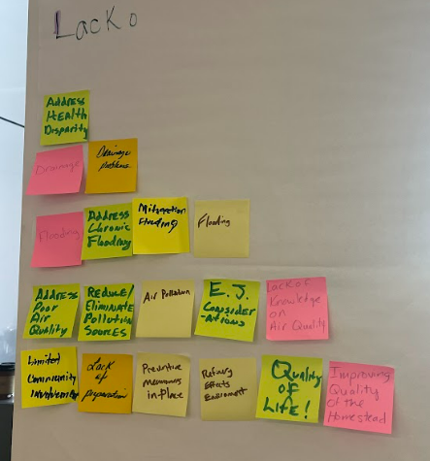

Activity 1: What are your community Issues?
Community Task Force

Low quality of life
Not much in place for the community

Air Quality and Flooding
Most toxic air in the country
High rate of cancer

Cities and counties aren't aware of the toxins and issues
Lack of Air monitors
Lack of knowledge overall in the community

Bad drainage and flooding affects students families the most “just a little rain completely floods some of our kids homes”

People left out of essential knowledge

Funds are allocated to the proper weak points of the community

Drainage District 7 map!
Water gets to rooftops of homes in district 7 which is a black community. The floods go through district 7 and it completely floods.

Poor water quality in homes
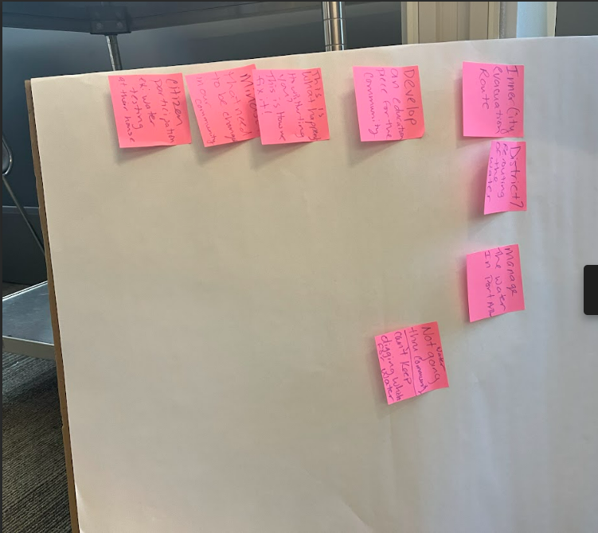

Activity 2: What are solutions to these Issues?
Community Task Force

Using streets to figure out how to reroute water
Finding exit points where water can be channeled

Inner city evacuation routes

Pollution Reduction
Pollution Laws

More studies to look at pollutants in all communities in the air, water, and land

Channeling all knowledge of what's happening to the community in diverse ways to widen reach

Simpler ways to present findings and issues
“This is what’s happening, This is how it’s happening, This is our plan to fix it”

Water purification gauges, water testers

Figure out an end goal and keep it in mind to the community

Technical Group Notes
What makes you proud to be a part of this community?
- Cs- : Never a dull moment
- J: Best people
- Cl: Well-connected
- K: Family-oriented community
- C: Family-oriented, community comes together to help each other
- D: Valuable resources this community provides to the rest of the world
- E: Availability of natural resources and tributaries
- A: People helping people and natural resources
Technical Activity 1
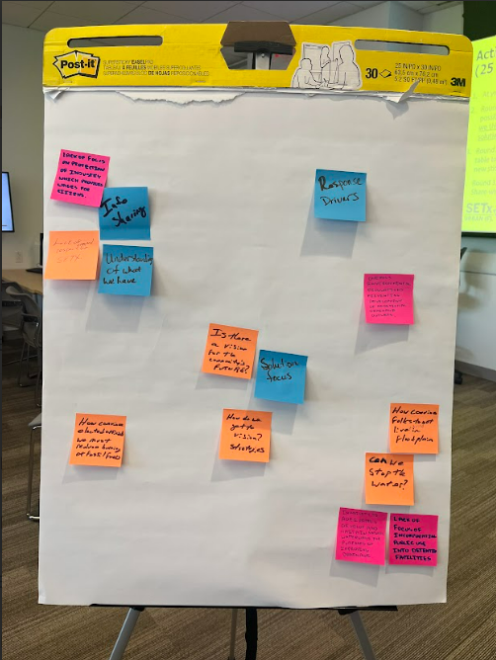
Ay
E
D
A
- Issues with info sharing and understanding
- How many products do we utilize from our area?
- Do people know about our air monitoring?
- He does community chats with local people on air monitoring and where to find data
- Response/water removal is the most important part of flooding recovery
- Info-sharing/solution-focused
D
- Sometimes “solutions” are not reasonable
- Is perfect air quality cost-effective?
- Doesn’t want to lose jobs and industry
E
- (in response to D) Then why are your cancer rates so high?
- People are making millions of dollars burning fossil fuels, so why not spend some of this on improving air quality?
- There is a lack of respect and regard for Southeast Texas. They want to take our oil and gas, but not help when we are in need. They only want to use and abuse.
- What is the vision for this community? How do we provide jobs in the future without oil and gas? How can we convince officials to reduce the burning of fuels?
- We can’t stop the water. How do we stop people from living and building in the floodplain? We have lost some of the floodplain to development
D
- Lack of focus on protecting industry and jobs. We need to protect where citizens go to work.
- Lack of focus on detention facilities and making them dual-use areas for community members
- Environmental regulation prevents the development of additional drainage outlets.
- Developing and maintaining natural waterways. There is funding for cleaning the bayou, but they can only remove fallen trees. Not allowed to do dredging work or remove silt build-up from development.
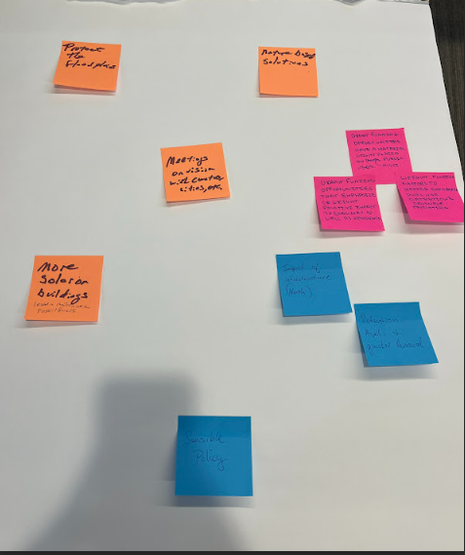
Technical Activity 2
E
- Need a representative from Entergy (Beaumont electrical company)
- They want our water too, they have no regard for water conservation
- We need to protect the floodplain. Implement nature-based solutions and more solar power in buildings like HEB and Walmart.
- How do we get people to care about Southeast Texas?
- Pine Island Bayou and Neches River goes up to Northeast Texas and worsens flooding
D
- We are the stepchild of the state. How many petrochemical products go through Port Neches?
- You can only build so many detention facilities
- The Toledo Bend Dam is 100 miles North. Opening floodgates flood Dewey County. Water from flooding in Dallas and Sabine River extends to Northeast Texas
- NEED grant funding opportunities for dual-use detention ponds. Hardin County doesn’t have the money to do so.
- Benefit-cost analysis of funding for the region only takes residents into consideration, not industry. Ranking criteria does not even consider industry.

A
- Infrastructure from the North is causing flooding to be worse here
- Retention availability. We need to get water out faster. We need to manage dredging through hazard waste programs. Dredging for water removal. Beaumont runoff to Hildebrand
- North Texas folks don’t even think about not building on the floodplain
Overall:
- Sabine and Neches River begin in Northeast Texas
- Look at infrastructure in the North
- Retention availability and quicker removal
- Sensible policy
- Need grants for community projects

