SETx-UIFL Co-Design Site Selection Summary
Authors: H J

Overview
It is the goal of the project to identify sites or locations in the five-county area (Jefferson, Orange, Hardin, Jasper, Newton) for which the Task Force and research team can work together to develop additional strategies to reduce risk (for example, flood risk) through a co-design process. The vision of the Co-design Team is to develop and implement a co-designed process ( collaborative work joined by researchers, residents, and decision-makers) to link air, hydrologic, & climate modeling & observations with residents’ knowledge & preferences for developing equitable adaptation strategies focused on climate-related acute & chronic stressors. This paper outlines how the SETx-UIFL identified and narrowed down sites to develop strategies to reduce risk, including the process, data collection, and integration, roles of the task force and research teams, and next steps.

In the spirit of the Co-Design Team's vision, the Task Force's role in the site selection process is to initiate the generation of potential sites for developing equitable adaptation strategies, review and consider data and analysis generated from the research team, and further refine the site list to a priority list of sites based on the best available information, researcher recommendations, and applicable local context. The role of the research team is to provide data and analysis on flood hazards, air hazards, and equity and social vulnerability, review those data and analyses against potential sites identified by task force members, and provide recommendations and data summaries to the task force for final consideration in narrowing down its list of sites for adaptation strategy development.
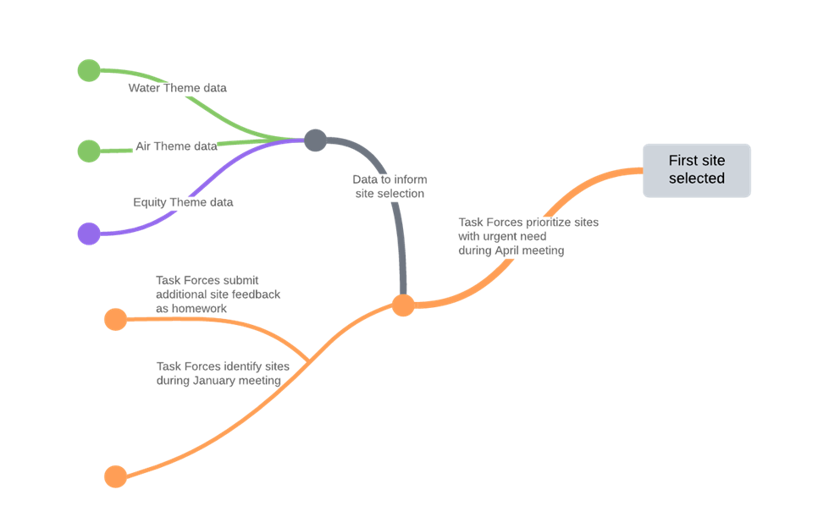
Figure 1: Site Selection Process Flow Chart; Source: Jaimie Masterson, Texas Target Communities

Formation of Effective Working Groups
The SETx-UIFL has two task forces: the Community Organization Task Force and the Technical Task Force. The task forces were initially formed in 2023, but new members are expected to be added in summer 2024. The Community Organization Task Force (COTF) is meant to provide local lived knowledge, act as the community champions for the project, is mission-oriented, represents different parts of the region, and is the research team’s primary connection to study area residents. The COTF is made up of members from the Jefferson County Precinct, Tekoa Academy STEM School, Charity Productions, Community In-Power and Development Association, and the Port Arthur Community Action Network. The Technical Task Force (TTF) provides local technical knowledge and subject-matter expertise, represents local and regional government, agencies, and industries, and members participate as part of their professional positions. The TTF is made up of members from the Southeast Texas Regional Planning Commission, the Big Thicket Biosphere Reserve, ExxonMobil, the Orange County Drainage District, Jefferson County Drainage District 7, and Jefferson County Drainage District 6.

Establishing Ground Rules
The UIFL team discussed ground rules for engagement with the task force and gave a research update on the project. After introducing the idea of ground rules to the task force, the following ground rules were identified by the members as necessary for continued collaboration:
- Make sure everyone has the opportunity to speak
- Make sure all voices are at the table
- Limit tangents, stay on topic, limit monologues, ask questions
- Start on time, end on time
- Being prepared ahead of time and ready to participate
- Seek clarification and test assumptions
- Have an open mind to all voices

Brainstorming Sites
On January 5, 2024, two task forces held a meeting to start brainstorming potential sites and areas of concern that the team could work together to co-design strategies. The purpose of the meeting was to achieve three objectives: first, to describe the criteria for site selection; second, to identify potential sites in the five-county area; and third, to share names and contact information for "point persons", organizations, and institutions in or nearby the sites. These point persons would support working with the research team to develop additional strategies to reduce risk. After establishing ground rules, the task force received an update on the research progress. This was followed by a general conversation regarding the implications and importance of research findings to date and future work. Most specifically, members of the task force agreed that research findings from the project should inform the criteria for site selection and potential site selection.

Site Identification Exercise
The Site Identification Exercise was conducted in two rounds. In the first round, task force members identified sites and locations based on various criteria such as high hazard risk (flooding and poor air quality), scale variability (parcel, neighborhood, watershed, etc.), social vulnerability, willing and active stakeholders, and local context. The local context included factors such as the location of the places and the people who would welcome them, and who would be interested in the data and models generated by the project. The group used a Locator Map (refer to Figure X) as a reference during the identification process.

In the second round, task force members were required to share specific names and contact information of key stakeholders of organizations/institutions in or near the identified sites. Due to time constraints, the task force members were asked to complete this task on their own as "homework". The research team developed a survey to record the responses of the task force members (described in another section below).

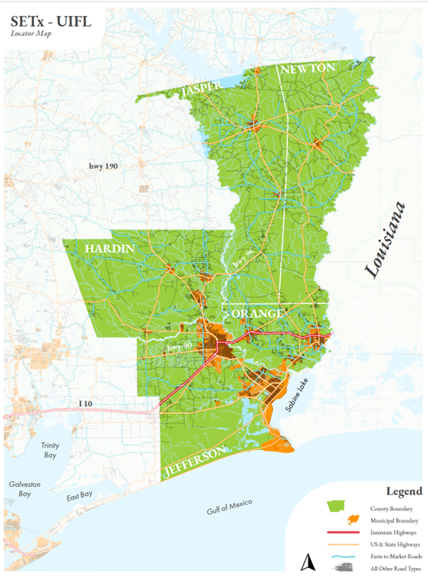
Figure 4: Locator Map, Source: S M, University of Texas at Austin

Summary of sites
Task force members identified 16 flooding sites and 2 air quality sites:
Site #1: El Vista - Port Arthur
Site #2: West 17th to 19th - Port Arthur
Site #3: Lakeside Dr. - Port Arthur
Site #4: 9th and Jimmy Johnson Blvd - Port Arthur
Site #5: Area Near Lincoln Middle School - Port Arthur
Site #6: Montrose - Port Arthur
Site #7: West Side of Port Arthur
Site #8: Air Team Site 1 - Beaumont
Site #9 Keith Road - Beaumont
Site #10: Lavaca St. - Beaumont
Site #11: Air Team Site 2 - Port Neches
Site #12: Central Buna
Site #13: Bevil Oaks
Site #14: Silsbee
Site #15: Sour Lake (West Side)
Site #16: Valinda Estates - Silsbee
Site #17: Longleaf Subdivision - Lumberton
Site #18: Sandy Creek - Jasper
Site #19: Rose Hill Acres
Site #20: East Groves

Survey
Texas Target Communities developed a survey for task force members to assess each potential site identified at the January 5, 2024, meeting regarding its stakeholders, prioritization, and other suggestions and concerns. The name of each site, a map of the site, and a list of four statements or questions were provided. First, the respondent was asked to assess agreement with the statement that there are stakeholders (organizations, institutions, state, and local offices and departments, etc.) who will engage in determining strategies. Second, the respondent is asked to assess agreement with the statement that there are stakeholders (organizations, institutions, state, and local offices and departments, etc.) that can implement strategies. The respondents are then asked if the site should be prioritized for the project to develop design and strategy interventions, followed by a request for any comments, suggestions, or concerns. The team gave respondents examples of more information, such as stakeholders and their contact information or suggestions they may have for site boundaries.

Table 1: Site Selection Homework Responses
Site # | Top Priority | Medium Priority | Low Priority | Not sure | Stakeholder Contact?
Site #1: El Vista - Port Arthur | 50% | 50% | 0% | 0% | Yes
Site #2: West 17th to 19th - Port Arthur | 20% | 20% | 0% | 60% | No
Site #3: Lakeside Dr. - Port Arthur | 0% | 20% | 0% | 80% | No
Site #4: Central Buna | 0% | 0% | 20% | 80% | No
Site #5: Bevil Oaks | 0% | 33.00% | 16.70% | 50% | Yes
Site #6: Silsbee | 0% | 33.30% | 0% | 66.67% | Yes
Site #7: 9th and Jimmy Johnson Blvd - Port Arthur | 20% | 0% | 20% | 60% | No
Site #8: Keith Road - Beaumont | 0% | 0% | 20% | 80% | No
Site #9: Sour Lake (West Side) | 0% | 20% | 0% | 80% | No
Site #10: Lavaca St. - Beaumont | 20% | 20% | 0% | 60% | No
Site #11: Area Near Lincoln Middle School - Port Arthur | 20% | 40% | 0% | 40% | No
Site #12: Valinda Estates - Silsbee | 33.30% | 0% | 0% | 66.67% | No
Site #13: Longleaf Subdivision - Lumberton | 16.70% | 0% | 16.70% | 66.67% | No
Site #14: Sandy Creek - Jasper | 16.70% | 0% | 0% | 83.30% | Yes
Site #15: Rose Hill Acres | 16.70% | 16.70% | 0% | 66.67% | Yes
Site #16: Montrose - Port Arthur | 20% | 0% | 0% | 80% | No
Site #17: West Side of Port Arthur | 20% | 40% | 0% | 40% | No
Site #18: East Groves | 0% | 0% | 0% | 100% | No

The task force site survey garnered a total of 6 respondents. The table above is a summary of the survey results. The first 4 columns (Top Priority, Medium Priority, Low Priority, and Not Sure) indicate the percentage of respondents who selected the priority level for the individual sites. Furthermore, a value of 20% in the “Top Priority” column indicates that 20% of respondents believed this site is a top priority for the co-design process. The last column indicates if respondents provided a stakeholder contact for each site. Most sites with identified stakeholders were in rural areas, likely due to the respondents' expertise. Based on these results, we decided to add a “Stakeholder Suggestion” activity to the next task force meeting to garner a wider understanding of stakeholders in the area. This activity is discussed in more detail below for the April 12th task force.

Data Integration
Equity, water, and air teams gathered information about the potential sites/locations to share with task force members, with the goal of the Task Force choosing one or more sites for additional strategy development.

Air
The Air Team looked at data for the two potential sites identified by the task force (Site #17: West Side of Port Arthur and Site #18: East Groves) and also for two sites identified as hotspots through their data analysis (Air Team Site 1 and Air Team Site 2). The overall map showing hot spots based on odors detected is seen below (Figure X). The maps depict odor hotspots, one indication of potential air quality issues for an area. The larger the black circle on the map indicates higher amounts of odor detected.
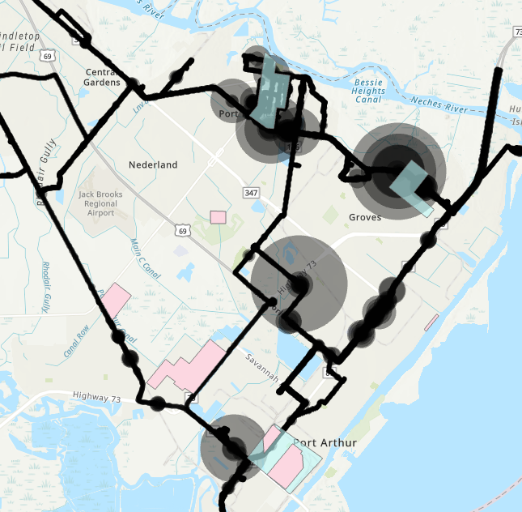
Figure 5: Odor Detection Overview Map for Southeast Texas Study Site
Air team

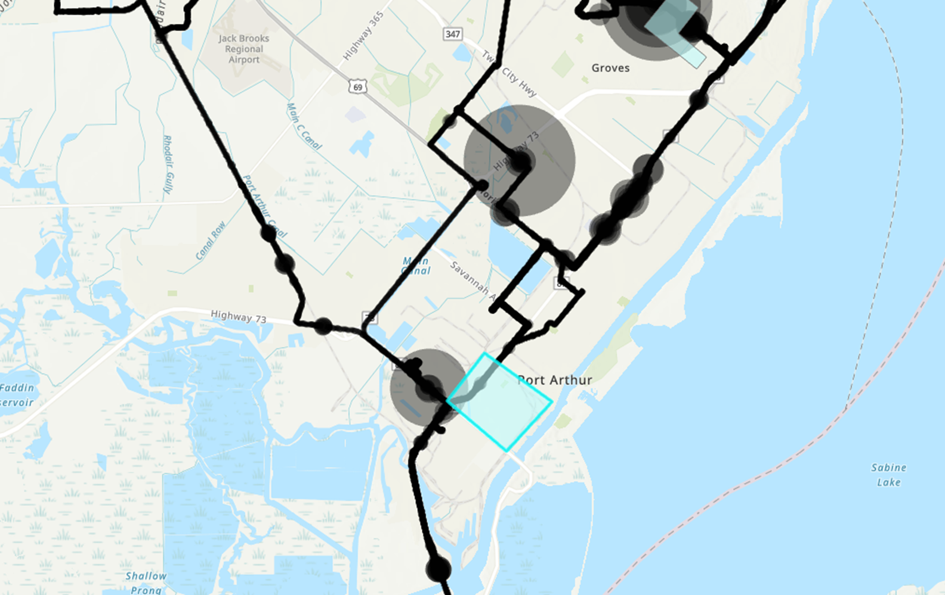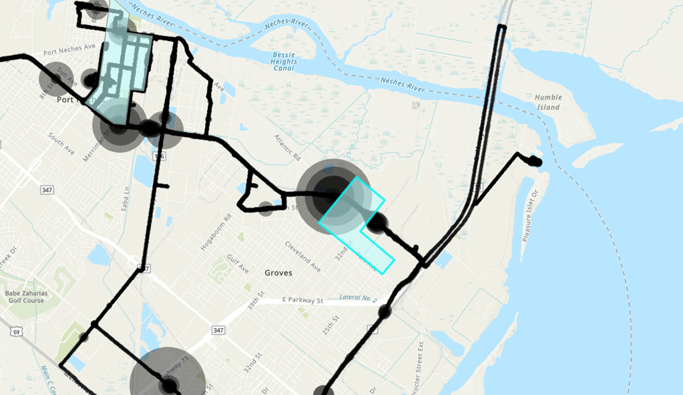
Figure 6: Odor Detection for Site #17: West Side of Port Arthur Figure 7: Odor Detection for Site #18: East Groves

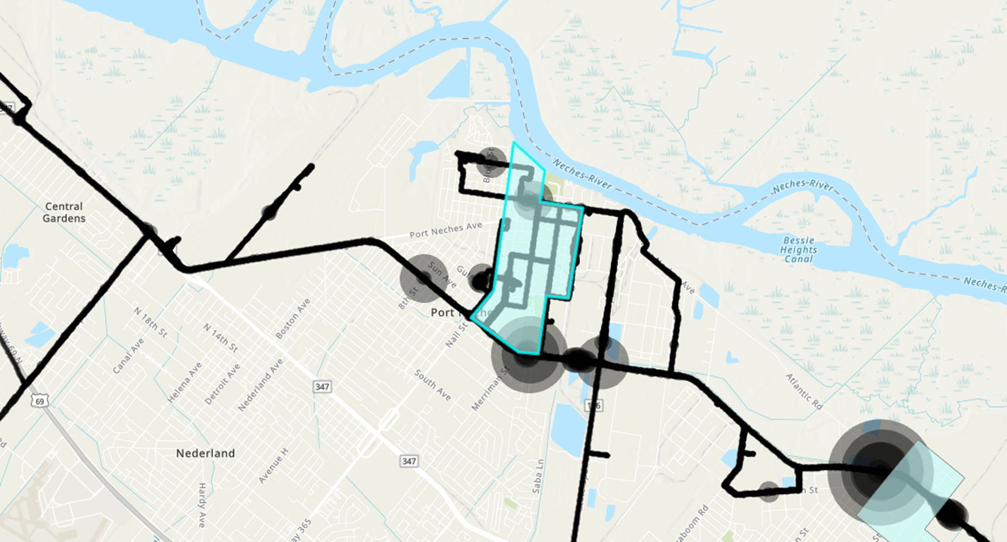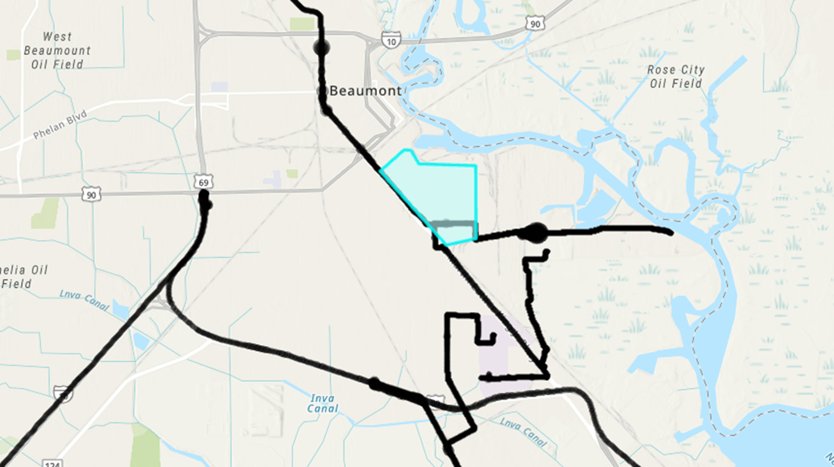
Figure 8: Odor Detection for Air Team Site 1 Figure 9: Odor Detection for Air Team Site 2

Water
The water team provided sensor data and Hurricane Harvey flood data to identify the region's hot spots of flood risk.

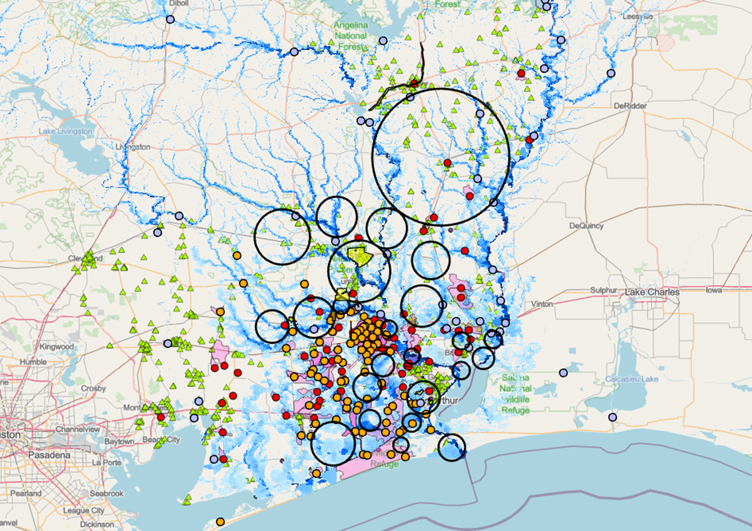
Figure 10:
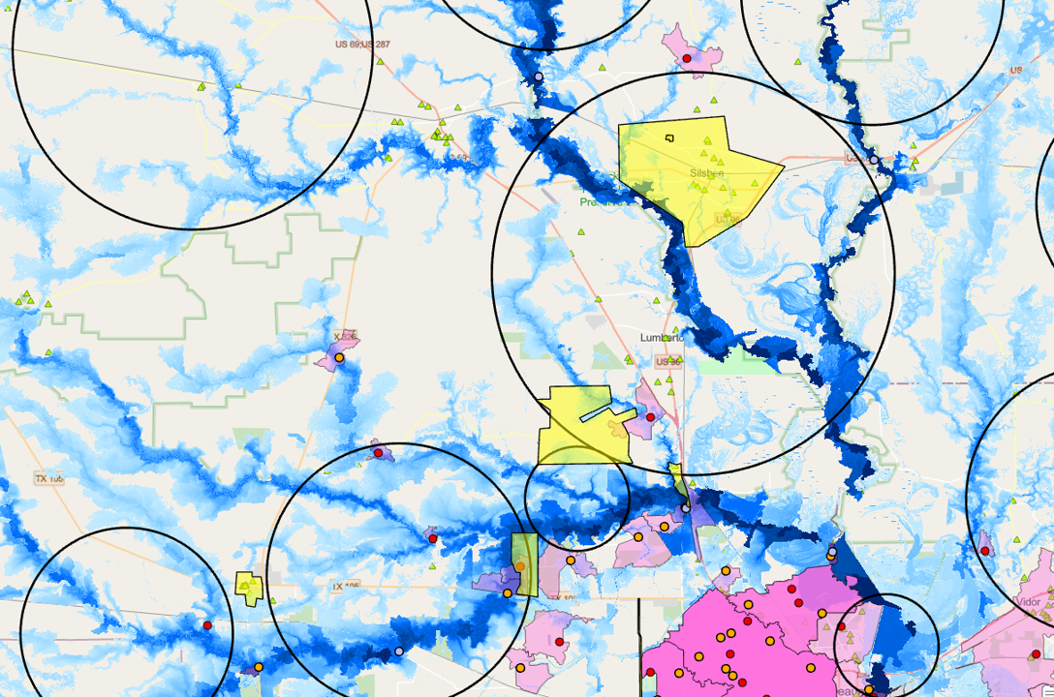
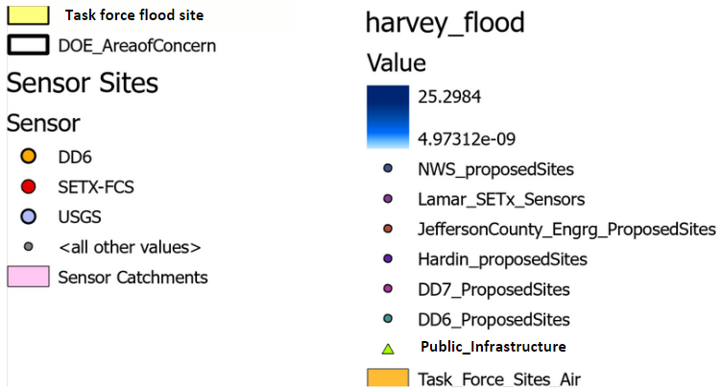
Figure 11:

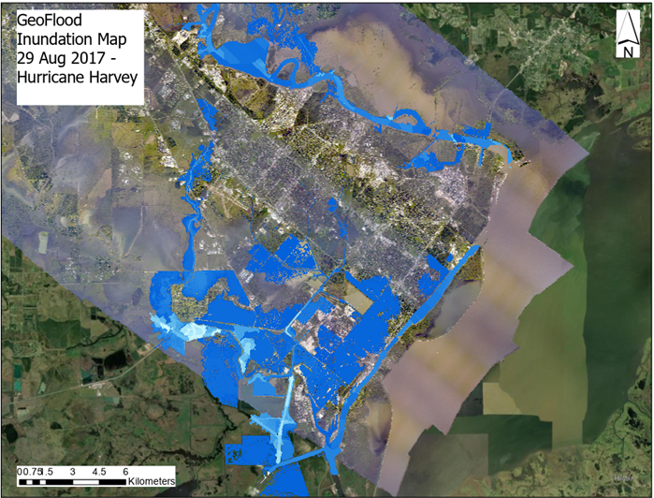
Figure 12: Hurricane Harvey Inundation Map

Equity
The equity research team assessed census and American Community Survey data to determine the percentage of households that are considered low-income (less than median income of $45,017), renters, or minorities, terming these categories “equity flags” across the region. For each potential site, researchers calculated the percentage of the population (with a 1000-meter buffer around each site) with zero equity flags and those with three equity flags. The researchers then ranked sites by vulnerability (those with higher percentages of the site population with three equity flags and those with lower percentages of the site population with zero equity flags). This process was conducted for comparison purposes at all flood sites, air sites, and the overall region (see Figure X: Equity Data Table). Researchers identified six flooding sites and two air sites that had greater than 20% of the population with three equity flags. Interestingly, the region as a whole shows 10.1% of the population with three equity flags, indicating that the sites identified for flood and air are more vulnerable than the average population of the region. The team also mapped the equity flag data to visualize the hot spots of areas with three equity flags (See Map: Comparison of Household Level Equity Flags with Flood Site Locations, Beaumont, Texas).

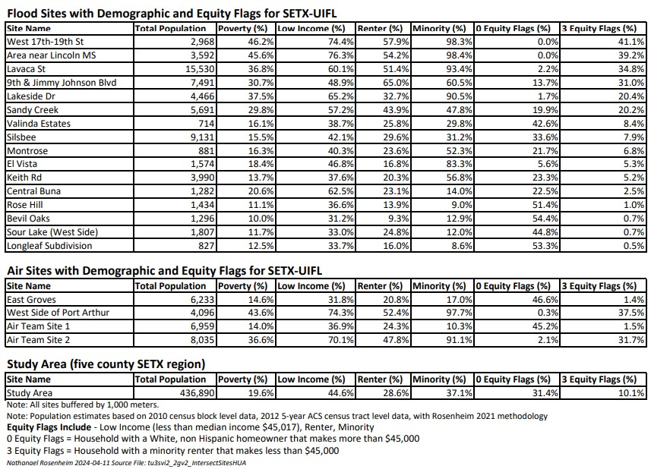
Table 2: Sites with Demographic and Equity Flags for SETx-UIFL by Nathanael Rosenheim
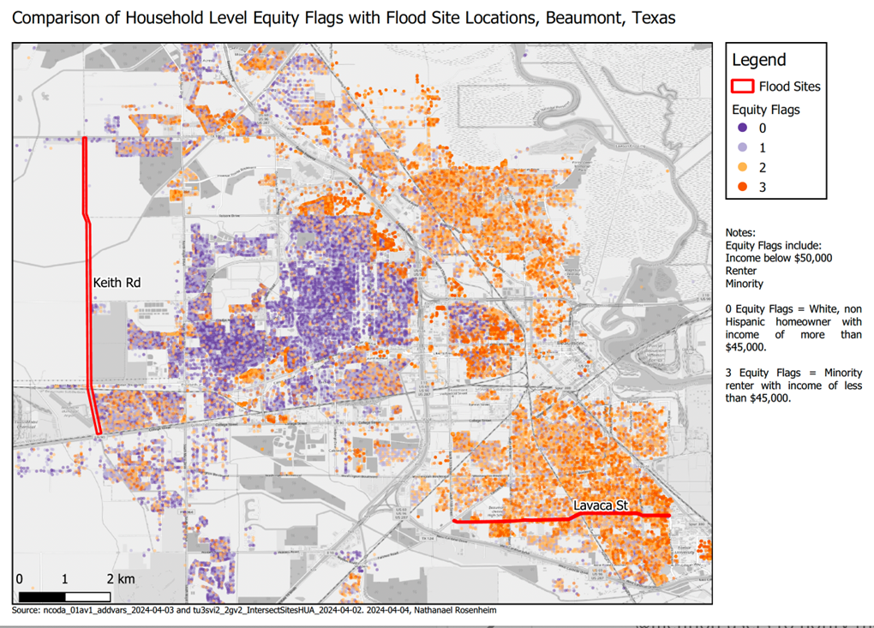
Figure 13: Comparison of Household Level Equity Flags with Flood Site Locations, Beaumont, Texas, by Nathanael Rosenheim

Narrowing Down the Site List
The task forces met again on April 12, 2024, to prioritize sites and choose a location to develop the co-design process. Six task force members attended, and they came from various backgrounds, including local nonprofits, law enforcement, drainage district 7, and Exxon Mobil.
We conducted 2 activities with task force members: a stakeholder suggestion circuit and a group discussion and consensus exercise to narrow sites down.

Maps of 20 sites were situated around the room with a blank stakeholder sheet for each site, grouped by geographical location. The stakeholder sheet included space for 7 themes: Elected Officials, City Staff, Businesses, Civic Groups, Religious Organizations, and Others. The task force members were then able to walk around to each site and record stakeholder contact information for applicable sites. This activity aimed to gauge possible stakeholder involvement for each site, as stakeholder involvement is a necessary component of the co-design process. Additionally, it was pertinent that task force members were able to relay possible stakeholder involvement stemming from their respective backgrounds and expertise.
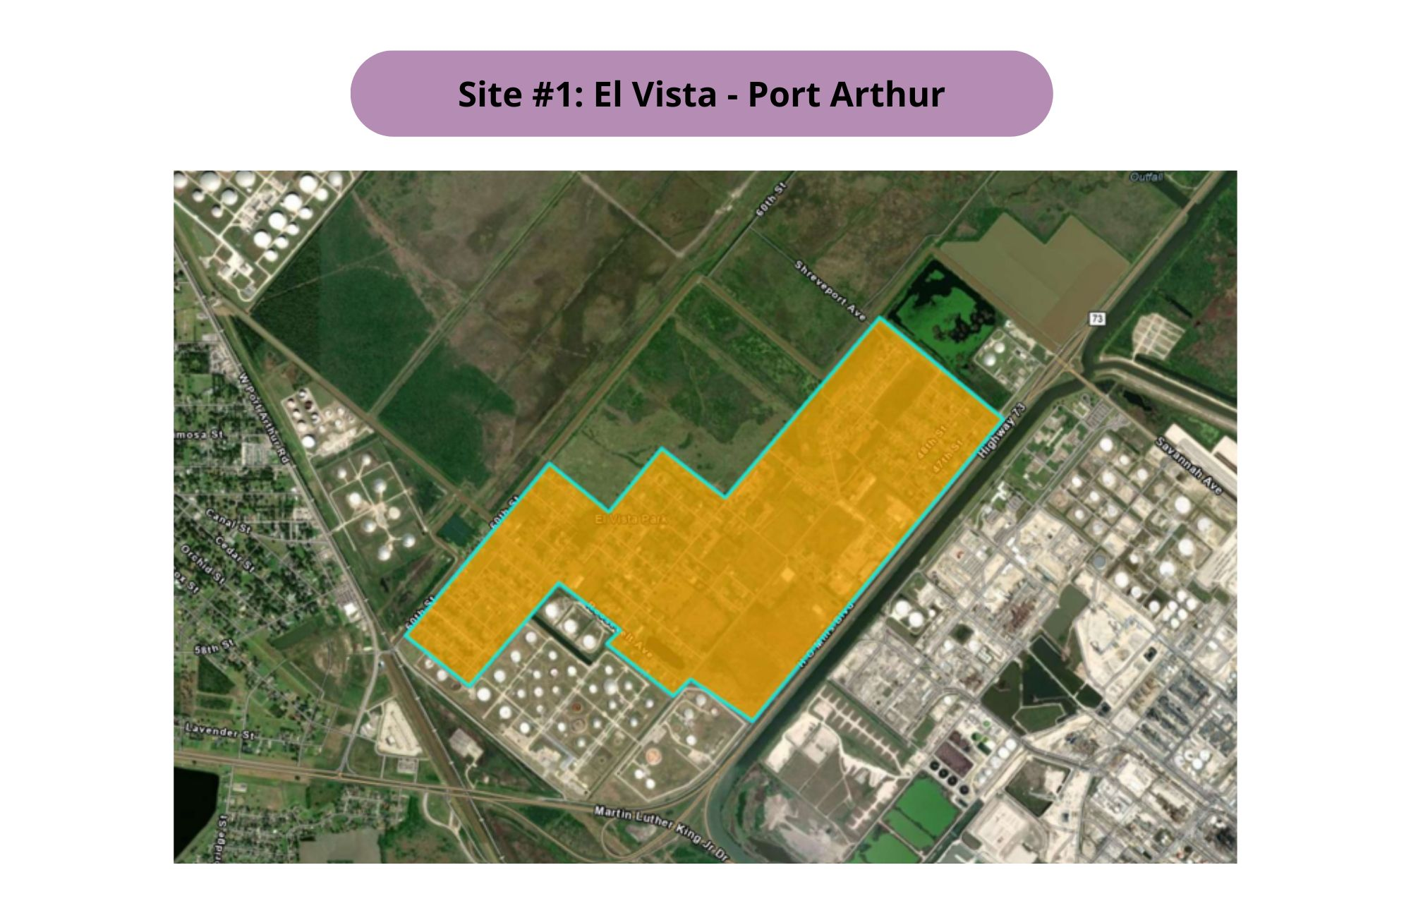
Figure 14: Example site photo

Following the Stakeholder Suggestion activity, task force members then discussed the 20 sites in a group setting to reach a consensus on one site to prioritize. During this activity, task force members were also given 3 data packets for the water, equity, and air themes. The equity packet included the table and map in Figures X and X, along with additional maps and information necessary for data interpretation. The water data packet included an overview of southeast Texas with multiple visual data points outlining potential sites, public infrastructure, Hurricane Harvey flood inundation, and more. The air data packet included sniffer data that visualized areas of air quality concern near proposed sites. Task force members were then prompted to discuss the availability of stakeholders, the reason for urgent need, and possible roadblocks for sites they wanted to prioritize. The results of the activity are shown and further description of each site combination discussed is included below.
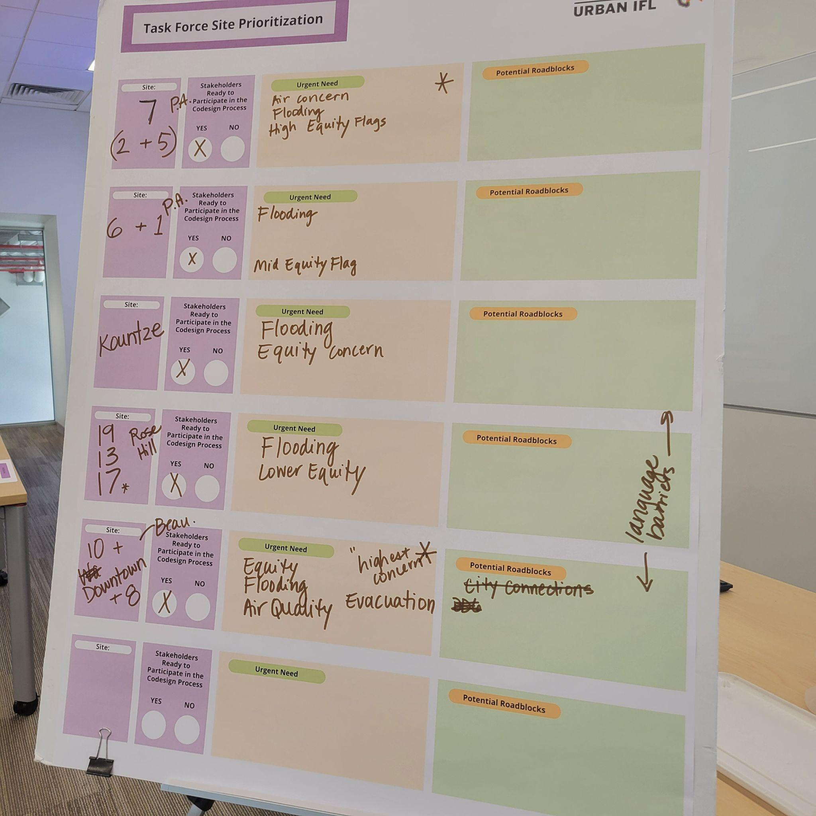
Figure 15: Group Discussion Results

Sites 2, 5, & 7
Sites 2, 5, and 7 were combined because they overlapped and because each represented an important area for air quality intervention in Port Arthur. Task force members identified about 10 stakeholders or organizations that would likely be willing to engage with the co-design process.

Sites 1 & 6
Sites 1 and 6 were combined as they are some of the most heavily impacted sites by flooding in Port Arthur. These two sites faced significant drainage issues and still faced severe flood inundation 3-4 days following Harvey. One task force member noted that creating a drainage system fit the area’s needs would be a largely expensive project requiring demolishing existing houses.

Kountze
Kountze was a new site suggested by task force members, but it was not originally included in our stakeholder activity discussed earlier. Members suggested this site be taken into consideration, as it had just been declared an emergency flooding event due to a recent storm in the area. Although we did not have a stakeholder sheet available for this site, one member commented that they knew many stakeholders who would likely be interested in getting involved with the co-design process. In the end, task force members agreed that while this site is important for consideration, it would likely take a backseat compared to the other existing sites.

Sites 8 & 10
Sites 8 and 10 were combined with the stipulation that additional surrounding areas on Washington Boulevard be included. This area has a long history of infrastructural and equity issues and has flooded during almost all storms in recent years, including Hurricane Ike, Rita, Harvey, Delta, and Tropical Storm Imelda. Additionally, Task force members predicted that we would have a lot of support from local organizations for a co-design process for this site and listed around 25 organizations and individuals as possible stakeholders.

Top Priorities
The 2 activities yielded a combination of sites as top priorities: Sites 2, 5, and 7 in Port Arthur (figure 17) and Sites 10 and 8 in Beaumont (figure 16). Task force members prioritized these sites based on flood risk, air quality concerns, stakeholder availability, and equity concerns by discussing sites as a group.

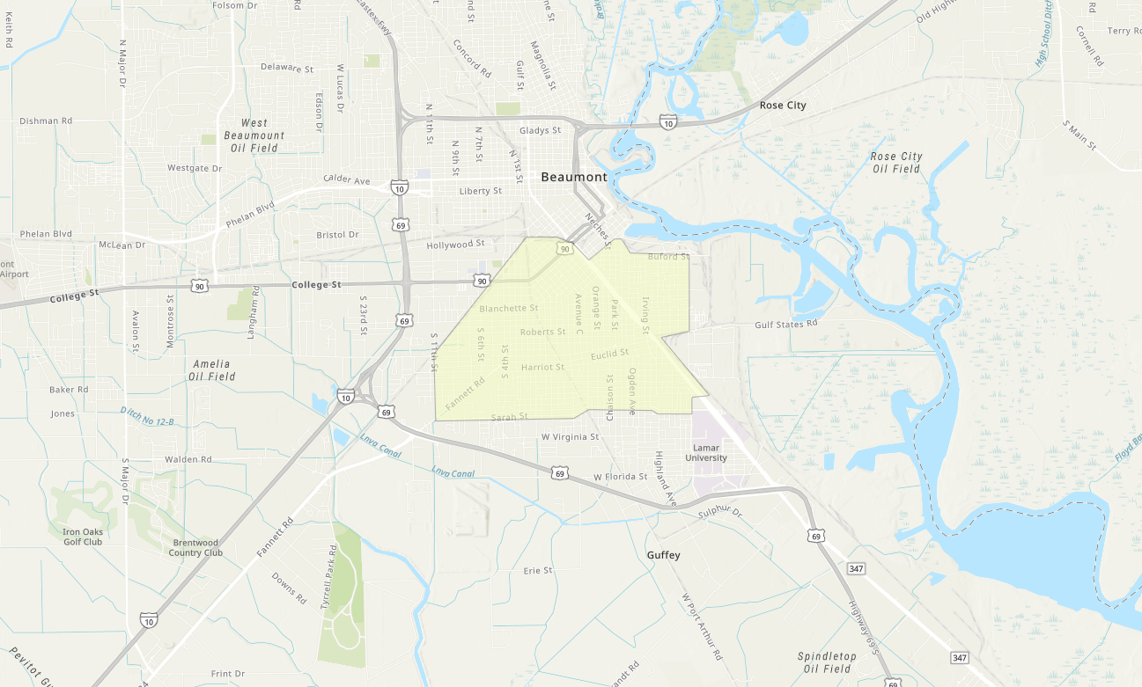
Figure 16: Beaumont Site

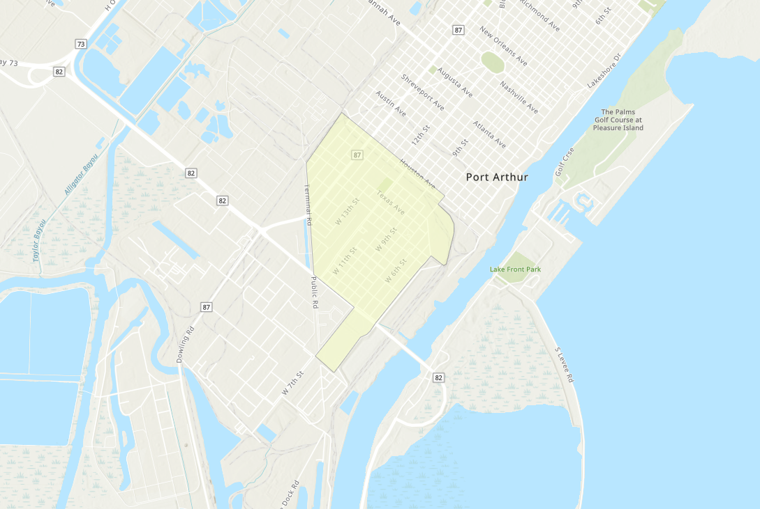
Figure 17: Port Arthur Site

