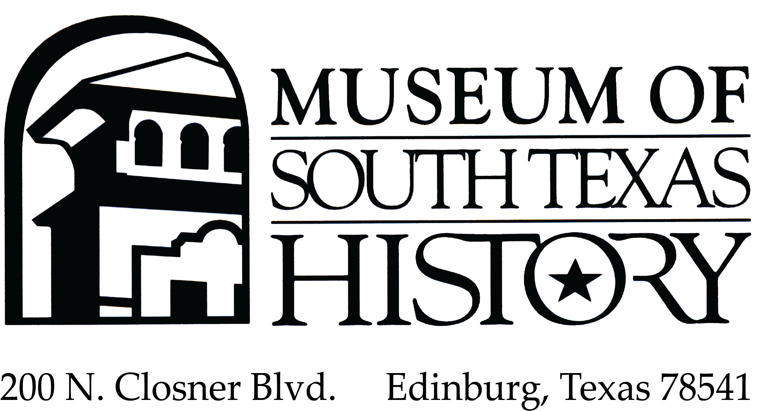

Oral History Project

Interview Release Form

I, _________________________, the interviewee, permanently give, convey, and transfer my oral history to the Museum of South Texas History (the “Museum”) for use in connection with the Museum’s efforts to collect audio- and video-recorded oral histories on the history of South Texas and Northeastern Mexico (the “Project”). I hereby grant to the Museum my participation in the Project, including but not limited to any interview, presentation, video, audio, photographs, statements, name, biographical material, images, likeness, voice, and written materials, whether provided before or after the date hereof, (collectively, the “Work”). I hereby grant to the Museum, at no cost, the perpetual, nonexclusive, transferable, worldwide right to use, reproduce, transmit, display, perform, edit, modify, synchronize, publish, prepare derivative works from, distribute, and authorize the redistribution of the materials in the Work in any manner or medium in perpetuity.

I understand it is currently the intention of the Museum to include the Project, which may include all or parts of the Work, in the Museum’s collection, but that the use of the Work is not limited to any such uses and that the Museum retains complete discretion on how and whether to use or retain the Work. Without limiting the generality of the foregoing, should any part of the Work at any time be found to include materials that the Museum deems inappropriate for retention with the collection or for transfer to other collections, the Museum may dispose of such materials in accordance with its procedures for disposition of materials not needed for the Museum’s collection.

I hereby release the Museum, and the Museum’s assignees and designees, from any and all claims and demands arising out of or in connection with the use of the Work, including but not limited to any claims for copyright infringement, defamation, invasion of privacy, or right of publicity.

I understand that the copyright to the Work and to any materials created by the Museum (or other parties to whom the Museum allows access) from the Work will be owned by the Museum or such other party as decided between them (or the Museum’s or such party’s designee or transferee, other than me). I also understand that this agreement does not, however, preclude any use I may want to make of the information I provide as part of the Work.

I agree to the terms, conditions, and restrictions set forth in this agreement:

________________________________________ _______________________________
Interviewee signature Date

____________________________________________ ___________________________________
Printed full name of Interviewee Address, including city, state and zip
____________________________________________ ___________________________________
Phone number E-mail address

