GAM Data Model – updated August 2023

The TWDB has developed the GAM Data Model (containing an ESRI ArcGIS File Geodatabase, Rasters folder structure, Table folder, projection files, current GAM Standards, and metadata guidelines) for use in collecting, organizing, creating, managing, and analyzing geographical information data sets used for Groundwater Modeling studies. Contracted consultants or researchers performing groundwater research for TWDB’s groundwater modeling funded studies are required to use the enclosed GAM File Geodatabase version 4.3.2 template as part of the contractual agreement.
Each vector-based dataset used in the research study must be included within the appropriate Feature Datasets of the file geodatabase structure. Additionally, all raster-based thematic datasets must be organized into the included theme-based subfolders within the Raster folder:
- ClimateGrids
- ConservationLandUseGrids
- GeologyGrids
- GeomorphologyDEM
- GeophysicsGrids
- RechargeGrids
- SoilGrids
- SubSurfaceHydroHydraulics
- SubSurfaceHydroWaterLevels
- SurfaceHydro
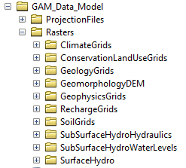
Please refer to the metadata descriptions within each of the theme-based Feature Datasets and/or raster datasets to determine the data storage location for each type of dataset used within the research study. If there are datasets used in the research study that do not fit into the specified vector Feature Datasets or the specified thematic raster subfolders included, please contact the TWDB Groundwater Modeling staff or the TWDB contract manager for additional instructions.

